2026 AIAMC ANNUAL MEETING
VENDOR PARTNER DIRECTORY

We encourage all attendees to visit the exhibitors located in Poinsettia 3.

Exhibitors will be available throughout the conference; be sure to visit them during the following dedicated exhibit hall times:

Thursday, April 16th 1:45 pm – 2:30 pm
Friday, April 17th 7:00 am – 8:00 am, 9:00 am – 9:30 am, and 12:00 pm – 1:00 pm
Saturday, April 18th 7:00 am – 8:00 am and 10:00 am – 10:30 am

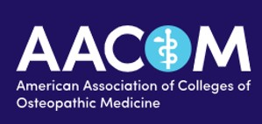

AACOM: Gold Sponsor
www.aacom.org
301-968-4100
Robert A. Cain, DO, President and CEO

On-Site Representatives:
Bob Cain, DO
Alegneta Long

Farida Ahmed

Founded in 1898, the American Association of Colleges of Osteopathic Medicine (AACOM) is the leading voice for the education and training of physicians who practice osteopathic medicine in settings across the medical spectrum—from primary care to the full range of medical specialties. We support our member colleges of osteopathic medicine in their efforts to attract and train individuals who are fueled by a desire to make a difference in our healthcare system by treating the whole person and building a future emphasizing health and wellness for all people. Today, more than 38,000 future physicians—close to 30 percent of all U.S. medical students—are being educated at one of our colleges of osteopathic medicine.
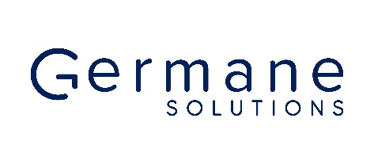
Germane Solutions: Silver Sponsor
germane-solutions.com
336-266-8627
Susan Hearn, CEO
shearn@germane-solutions.com

On-Site Representatives:
Susan Hearn
Hunter Rich
Katrina Anderson

Germane Solutions is a national boutique healthcare consulting firm distinguished by its comprehensive service offerings and specialized expertise in Academic Medicine and Graduate Medical Education (GME). Comprised of seasoned professionals with profound GME experience, Germane Solutions excels in delivering holistic solutions tailored to meet the diverse needs of hospitals, health systems, and healthcare organizations.

Germane Solutions guides healthcare executives through a spectrum of services aimed at advancing their organizational objectives. Our commitment lies in delivering data-driven solutions and strategic approaches geared toward enhancing access to high-quality healthcare services.

Founded with a mission to provide excellence to our clients and a vision to revolutionize the delivery of Academic Medicine and GME, Germane Solutions has done exactly that.

We offer our valued clients a comprehensive suite of services including strategic planning, financial consulting, operational optimization, accreditation support, and community and population health consultative services.

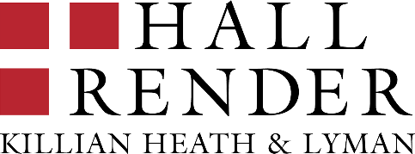

On-Site Representative:
Scott Geboy had a late conflict and can no longer attend. Company materials will be available at the Hall Render table.
Hall, Render, Killian, Heath & Lyman, P.C.: Bronze Sponsor
hallrender.com
414-721-0451
Scott Geboy, Attorney
sgeboy@hallrender.com

The mission and vision of the Alliance of Independent Academic Medical Centers (AIAMC) is to serve as a learning organization of independent academic medical centers. As an AIAMC Vendor Partner for the last ten years, Hall, Render, Killian, Heath & Lyman, P.C. applauds the AIAMC’s commitment and strong position as a leader in supporting independent academic medicine.

Hall Render has focused intently for many decades on matters important to health care organizations, including academic medicine. Whether your legal needs relate to Medicare and other GME funding, rural reclassification, multi-campus hospitals, PATH, ACGME accreditation, Teaching Health Centers/Rural Health Clinics, or resident termination and discipline, Hall Render is committed to the health care industry and serving the needs of teaching hospitals, non-hospital teaching sites, and academic teaching institutions.

CONTACT US
Look for our booth during the AIAMC Annual Meeting from April 16 to April 18, 2026 and/or contact Scott J. Geboy, J.D. at sgeboy@hallrender.com or 414.721.0451 with any questions.

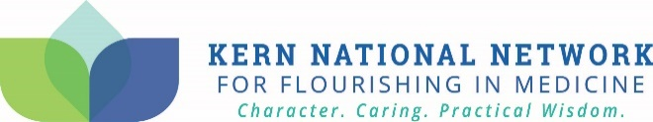
Kern National Network: Bronze Sponsor
https://knncaringcharactermedicine.org
262-955-4658
Anna Hassell, Project Coordinator
ahassell@mcw.edu

On-Site Representative:
Sarah Ozurumba

The KNN is a national movement to advance flourishing across the health ecosystem through a framework of character, caring, and practical wisdom. We partner with health institutions to unlock their full potential and achieve excellence through flourishing-centered cultures that transform organizations and elevate everyone.

Our strengths-based methods combine a robust guiding framework, scholar-practitioner approaches, deep subject matter expertise, and national peer collaboration to solve complex culture and workforce challenges. We help institutions harness their strengths to build cultures where all who learn, work, receive care, or lead in health can flourish.
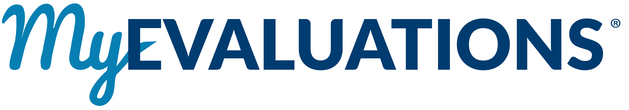
MyEvaluations: Bronze Sponsor
www.myevaluations.com
646-422-0554
David P. Melamed, MD, CEO
david@myevaluations.com

On-Site Representative:
David Melamed, MD

MyEvaluations helps independent academic medical centers turn assessment and accreditation work into something practical, efficient, and meaningful. Built by clinicians for real-world GME environments, our platform uses AI to reduce administrative burden while improving the quality of evaluations, feedback, and program oversight. From narrative-driven assessments and milestone alignment to CCC-ready dashboards and institutional reporting, MyEvaluations transforms everyday clinical observations into actionable insight. Our AI tools support faculty with guided prompts, reduce variability and bias, and help leadership see trends without adding extra work. The result is clearer decisions, stronger learner development, and better alignment with accreditation and quality goals. At the AIAMC 2026 Annual Meeting in Carlsbad, we look forward to partnering with teaching hospitals and health systems that value independence, innovation, and outcomes that truly support education, operations, and patient care. Let’s make GME work smarter, together.

Paradigm Medical Systems: Bronze Sponsor
www.paradigmmedicalsystems.com
971-570-4244
Bridget Cartwright, President
bridget@parmedsim.com

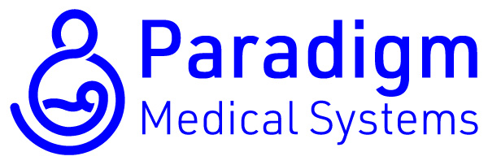

On-Site Representatives:
Bridget Cartwright
Aidan Hart

Specialists in realistic OB/GYN and childbirth simulation. Providing class leading task trainers, hand-built using unique materials and designed for clinical fidelity to drive development of useful muscle memory. A proprietary flesh-like material is molded around functional skeletal systems to create a platform with remarkable tactile realism, enabling lifelike application of complex maneuvers alongside key micro-skills.
Our most popular model, Sophie and Her Mum, pairs a fetal model that is birth weight (7.5 lbs) and has a fully articulated skeletal system with a maternal pelvic model containing a replica bony pelvis. The result is a highly precise simulation for skills ranging from basic hand placement to posterior arm retrieval. Our other models accommodate specific skillsets, such as OVD, pelvic exams, and cervical checks.
Bring remarkable realism to common procedures alongside low-volume high-risk emergencies, improving outcomes for educators, providers, and patients alike. Experience the gold standard in women’s healthcare simulation for yourself!

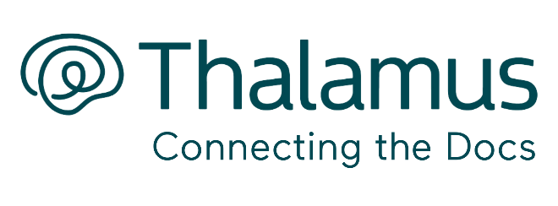
On-Site Representatives:
Terri Feist

Thalamus: Bronze Sponsor
www.thalamusgme.com
281-630-4711
Brooke Moore, Dir. Strategic Partnerships
brooke.moore@thalamusgme.com

Ashley Page

Thalamus is a public benefit corporation and the premier, cloud-based interview management platform designed specifically for application to Graduate Medical Education (GME) training programs. The software streamlines communication by eliminating unnecessary phone calls/emails allowing applicants to book interviews in real-time, while acting as a comprehensive applicant tracking system for residency and fellowship programs. Thalamus provides comprehensive online interview scheduling and travel coordination via a real-time scheduling system, video interview platform, AI application screening/review tool (Cortex) providing technology-assisted holistic review, and first-in-class analytics dashboard (Cerebellum). Now featured nationally at over 800+ institutions, 8,000+ residency and fellowship programs, and used by nearly all applicants, Thalamus is the most comprehensive solution in GME interview management.

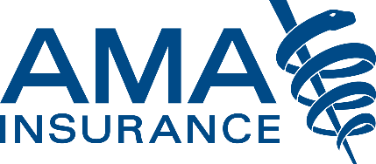

On-Site Representative:

AMA Insurance Agency: Exhibitor
amainsure.com
317-879-6988
Jackson Gleaves, Business Development Exec
jack.gleaves@amainsure.com
Jack Gleaves
Brian Farmer

AMA Insurance Agency is dedicated to protecting the medical community with tailored insurance solutions. We specialize in coverage for medical students, residents, physicians, and healthcare professionals, offering plans that safeguard both personal and professional needs.
New Offering: We now provide an innovative coverage option for Teaching Hospitals, insuring all employees under one comprehensive program while helping operationalize physician well-being. This solution delivers customized protection for faculty, staff, and trainees—reducing burnout, turnover, and absenteeism to support a healthier, more engaged workforce.
With deep industry expertise and a commitment to exceptional service, AMA Insurance Agency helps medical professionals focus on what matters most: their patients.

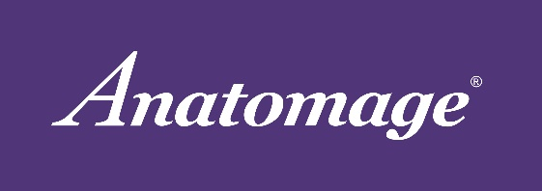
Anatomage: Exhibitor
www.anatomage.com
408-885-1474
Allie McDonald, Marketing Coordinator
allie.mcdonald@anatomage.com

On-Site Representatives:

Jason Malley
Paul Myatovich

Anatomage is a medical company, driving innovation through advanced solutions in hospitals and educational institutions. Our digital cadaver table, the Anatomage Table, allows a hands-on approach to learning the human body through unique visualization options, dissection tools, and quiz mode features, making it a strong asset to any anatomy class.

ERAS – AAMC: Exhibitor
https://engage.aamc.org/eras
202-862-6176
Patrick Fritz, Sr. Director of Admissions
pfritz@aamc.org
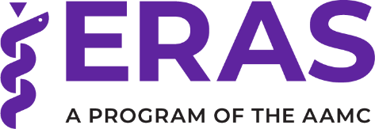

On-Site Representative:
Alexander O’Neill

The AAMC Electronic Residency Application Service® (ERAS®) program is a foundational part of the transition to residency ecosystem and supports students, programs, specialties, and schools. For over 30 years, the ERAS program has been the gold standard in medical residency and fellowship applications, trusted by over 131 specialties and more than 10,000 programs. Through our strategic collaboration with Thalamus, we are accelerating innovation in the transition to residency by enhancing interview scheduling, recruitment analytics, and mission-aligned selection and retention.

Look to the AAMC and ERAS program for:
- Secure residency application management.
- Data that is reliable, timely, and supports decision making.
- Resources like AAMC Careers in Medicine, FIRST (Financial Information, Resources, Services, and Tools), and Visiting Student Learning OpportunitiesTM (VSLO®) that help students prepare for a successful transition to residency.
- Partnership with other leaders in the transition to residency in providing the data that power the Residency ExplorerTM tool.

The AAMC has rapidly accelerated the pace of innovation across ERAS platforms. New features are transforming the way the ERAS program supports aspiring doctors and the entire medical education community. Learn more: https://engage.aamc.org/eras

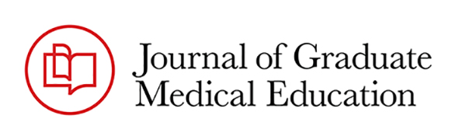

Journal of Graduate Medical Education: Exhibitor
https://jgme.kglmeridian.com/
Deb Simpson, PhD, Deputy Editor
deb.simpson@aah.org

On-Site Representative:
Deb Simpson, PhD

The Journal of Graduate Medical Education disseminates scholarship and promotes critical inquiry to inform and engage the graduate medical education community. JGME is open access, peer-reviewed, editorially independent, and published by the Accreditation Council for Graduate Medical Education.

